**Базы данных SNP и структурных вариантов человека. Влияние SNP на структуру белка.**

# **dbSNP**

<https://www.ncbi.nlm.nih.gov/snp/>

Другие базы данных -

Table 1. Six popular training datasets for tools predicting the effect of single point mutations.

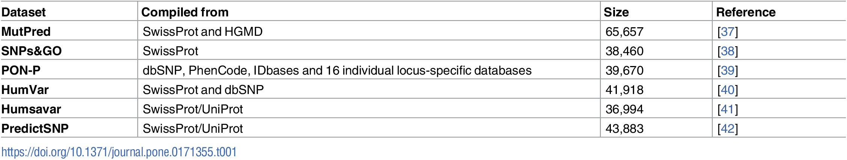

# **Статья**

# PLOS ONE 2017

# **Impact of genetic variation on three dimensional structure and function of proteins**

* Roshni Bhattacharya,
* Peter W. Rose,
* Stephen K. Burley,
* Andreas Prlić

RCSB Protein Data Bank, San Diego Supercomputer Center, University of California San Diego, La Jolla, California, United States of America

<https://journals.plos.org/plosone/article?id=10.1371/journal.pone.0171355>

### **Location of SNPs within 3D structures**

In the *Surface* category, it was observed that 52% (155 out of 297) of the SNVs map to *Loop* regions compared to ~34% for *Alpha_helix* and ~14% for *Beta_strand*.

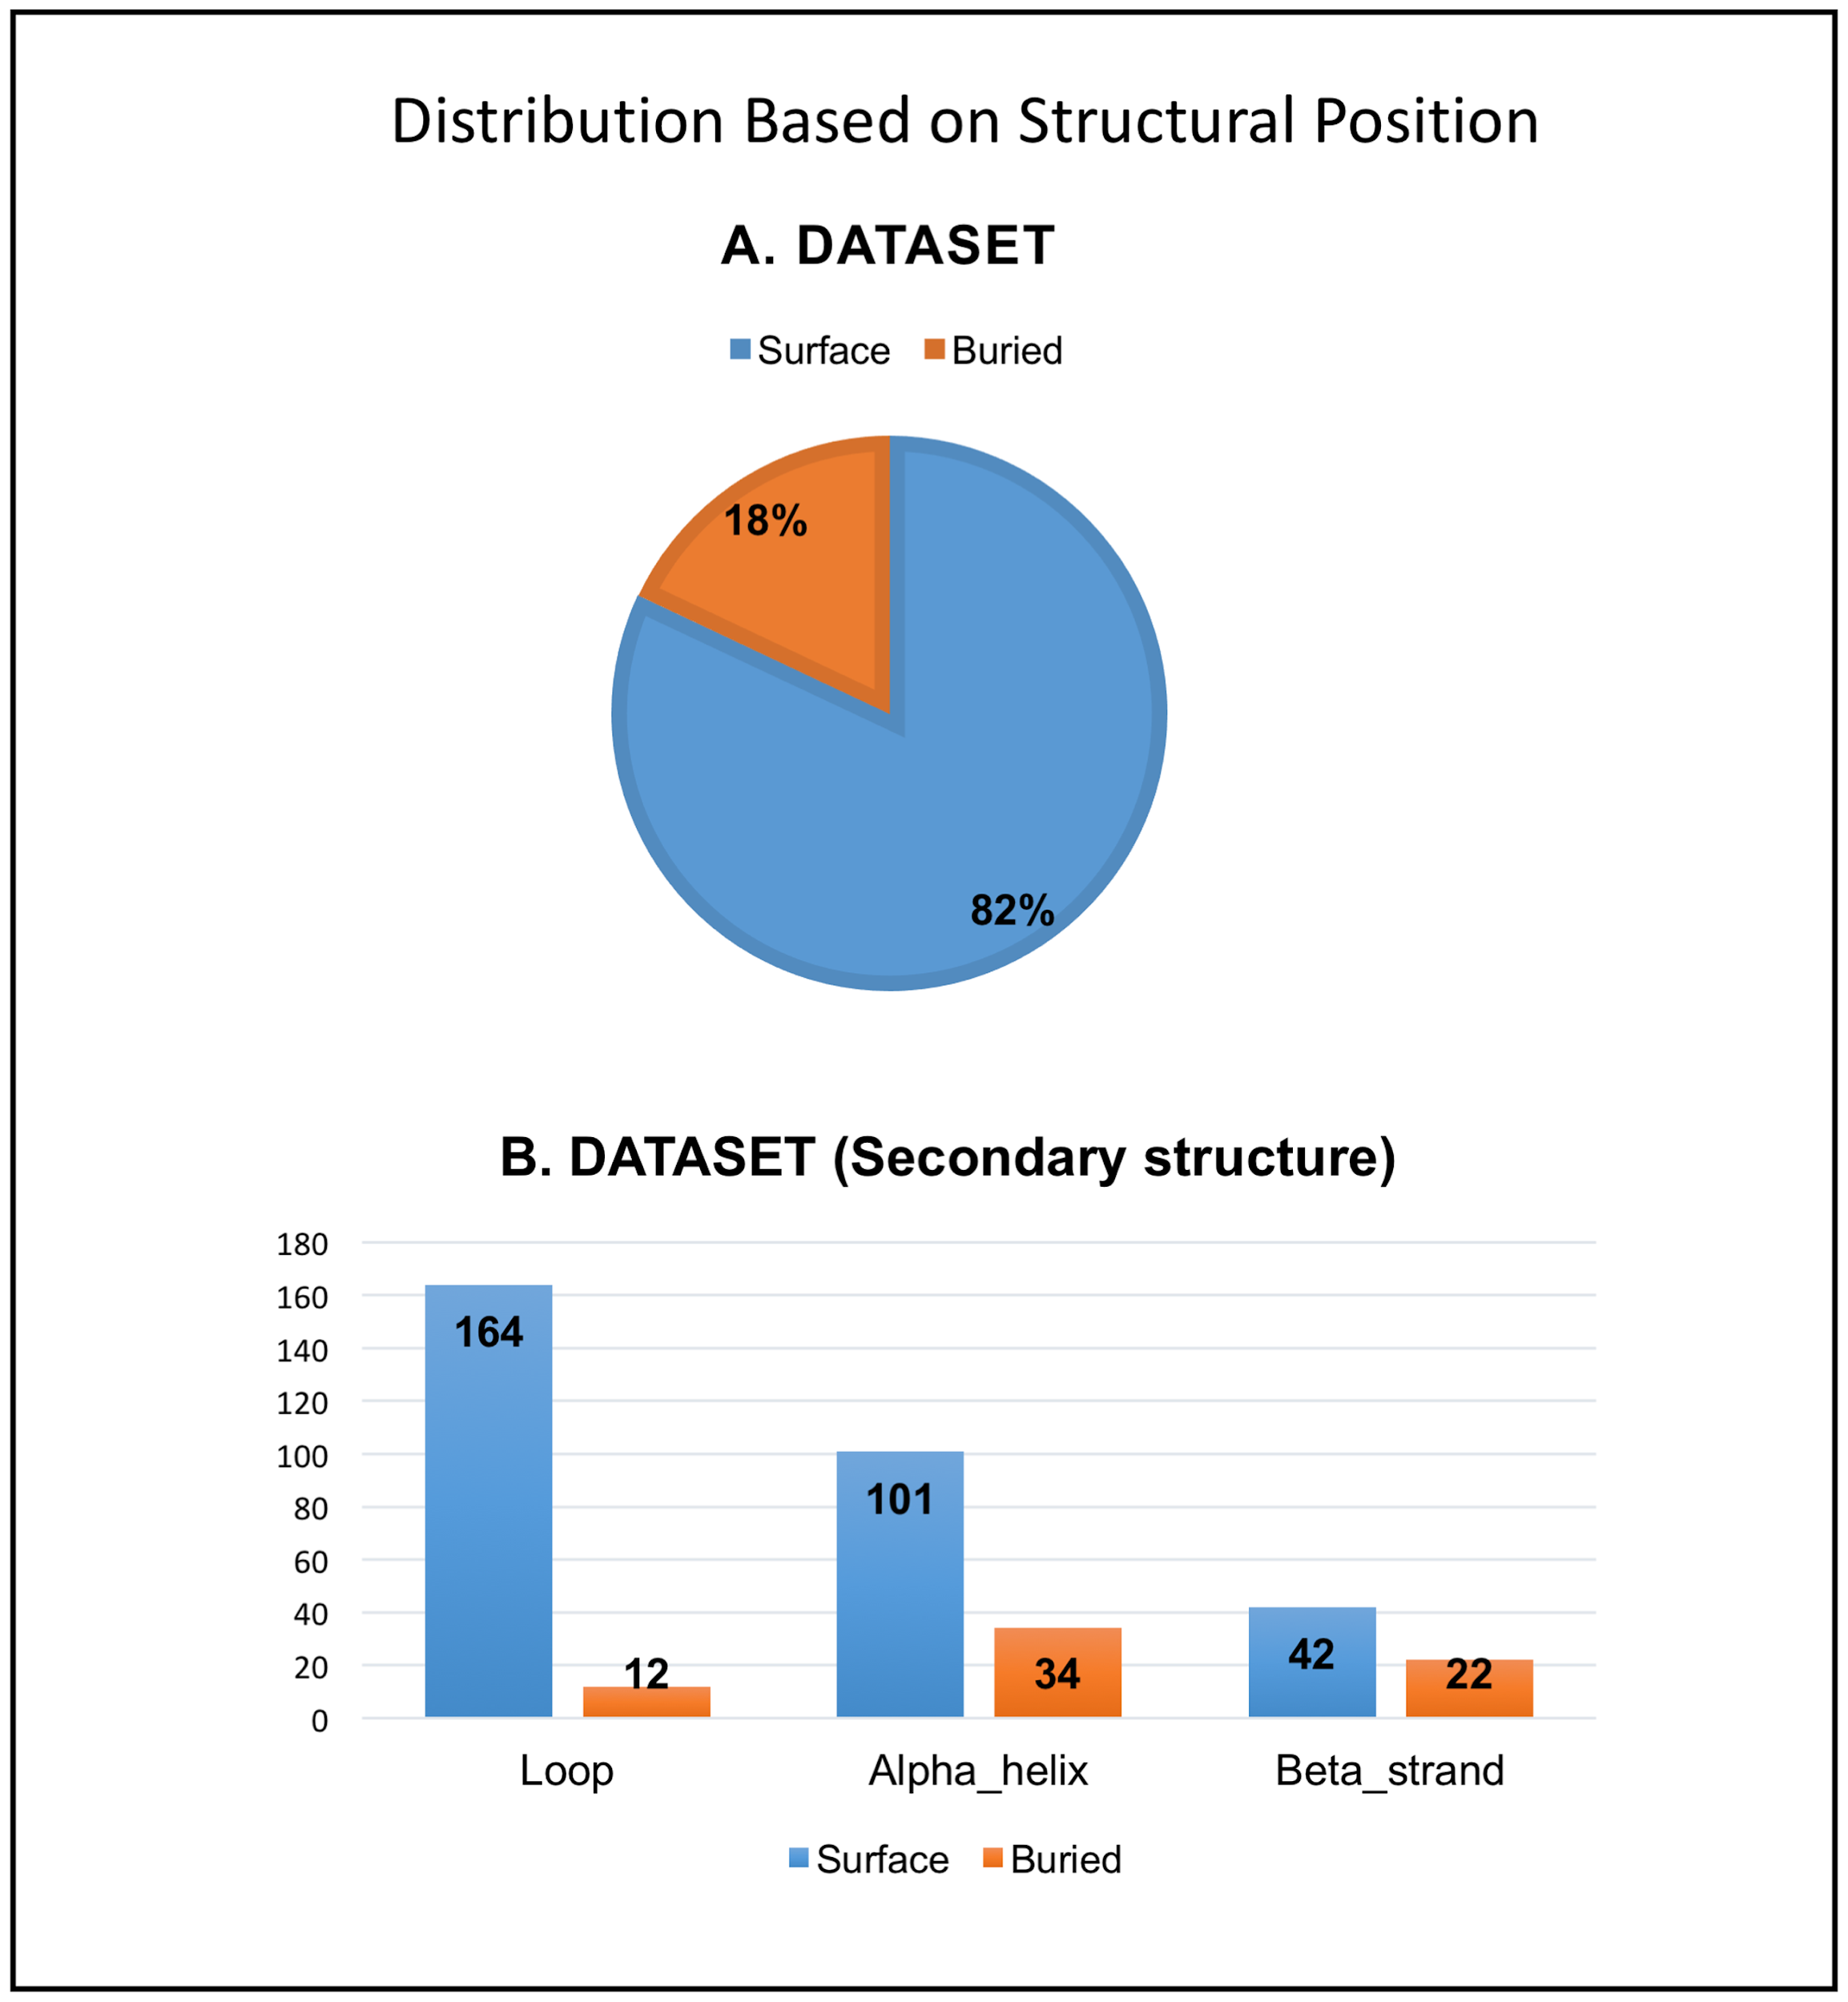

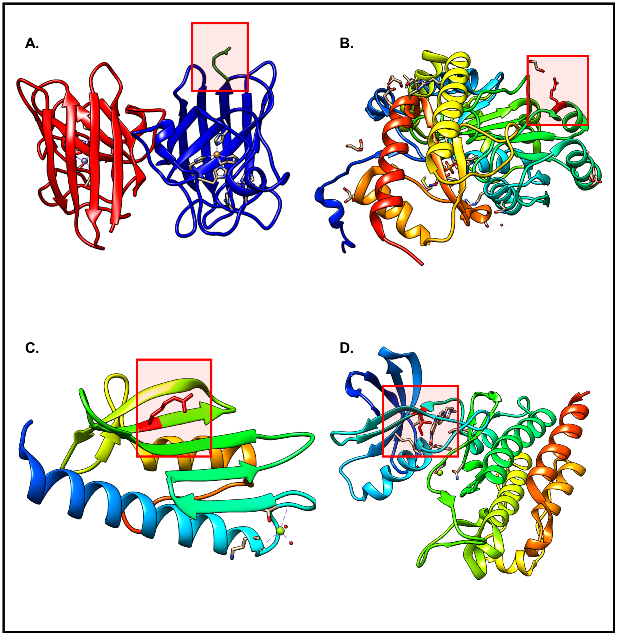

Fig 2. SNV consequences map to various locations within protein structures.

A) PDB: 1AZV, SNV: rs121912431 (G37R) is present on the surface of the protein in the highlighted Loop segment, where it causes the neurological disease Lou Gehrig’s disease. B) PDB: 1J04, SNV: rs121908529 (G170R) is present on the surface of the protein in the highlighted Alpha_helix, where it causes hereditary kidney stone disease primary hyperoxaluria type 1. C) PDB: 3S5E, SNV: rs138471431 (W155R) is present on the surface of the protein in the highlighted Beta_sheet, where it causes the neurodegenerative disease Friedreich’s ataxia. D) PDB: 2V7A, SNV rs121913459 (T315I) is present in the ATP-binding domain and causes resistance to the drug imatinib in patients with chronic myelogenous leukemia.

Table 2. Consequence of SNVs on protein structure and function for a dataset of 374 SNVs for which experimentally obtained atomic level data for the variation is available in the Protein Data Bank.

Each SNV can be scored for multiple categories.

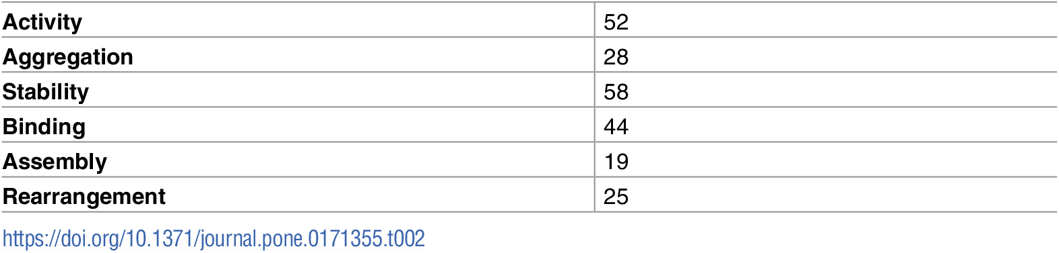

Table 3. Examples for each SNV related effect category.

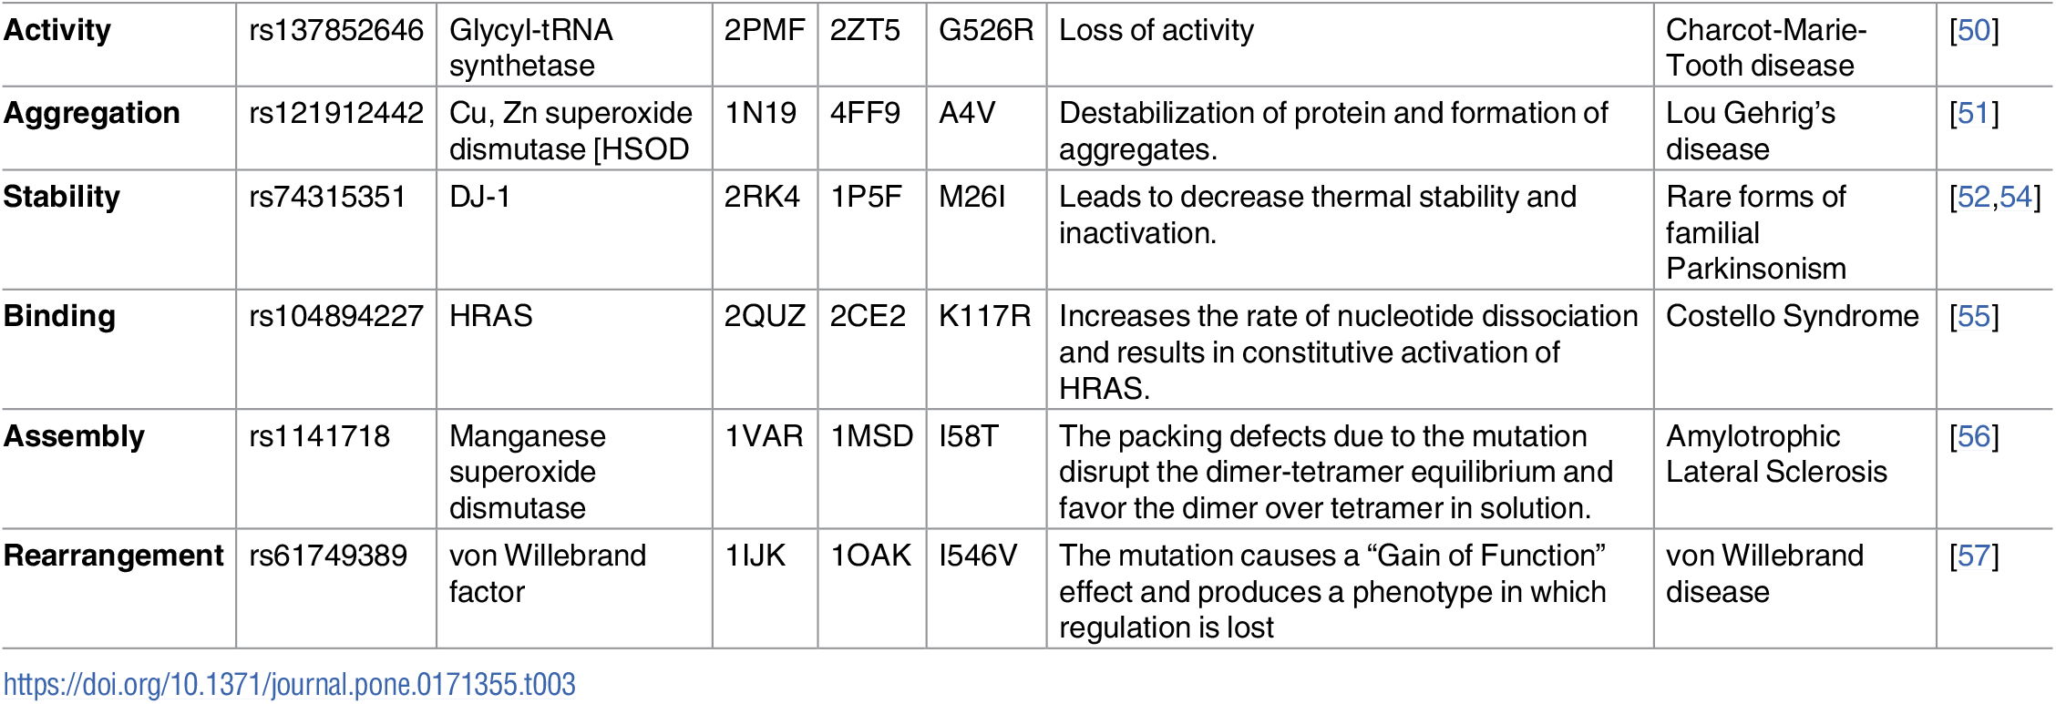

**Case Studies**

Скачать и установить Pymol

<https://pymol.org/2/>

Extra для домашнего изучения, не для урока:

Pymol for beginners: Labeling

<https://www.youtube.com/watch?v=nFY3EjBNPBQ>

Пример 1.

**SNVs that affect both protein structure and function.**

В Pymol загрузить структуру

File->Get PDB… 1E51

В правой стороне нажать на букву L (labeling)

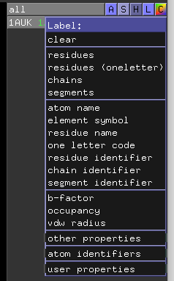

Попробовать разные способы нумерации остатков. Выбрать наиболее удобную.

Найти и изучить мутацию Pro→Leu mutation (P428L) на 3D картинке в Pymol. Найти описание rs28940893 в dbSNP и геномном браузере UCSC.

> select resi ### in ####

Arylsulfatase A (gene: ARSA) breaks down sulfatides. The Pro→Leu mutation (P428L) (rs28940893) mapping to amino acid 426 in the PDB structure yields an oligomerization defect (preferred mutant assembly is dimer instead of octamer as for wild-type (Wildtype PDB: 1AUK)) that increases the susceptibility of the protein to degradation by lysosomal cysteine proteinases, leading to severe reduction in half-life and metachromatic leukodystrophy. Therefore, this SNV related change affects both Stability and the protein Assembly.

Пример 2. **Activity.**

52 of 374 SNV related changes in our dataset (~14%) either increase or decrease protein activity.

human glycyl-tRNA synthetase (mutant PDB: 2PMF) loses detectable enzymatic activity due to a G526R (rs137852646) mutation, which is causative of Charcot-Marie-Tooth disease. G526 is an evolutionarily conserved residue located in the midst of motif 3 that connects *Beta_strand* β19 with *Alpha_helix* α13. With the exception of the mutation site, the overall structure of the G526R mutant protein is almost identical to that of the wild type (Wildtype PDB: 2ZT5) enzyme (alpha-Carbon atomic position root-mean-square deviation = 0.8Å). Although the G526R change does not disturb the positions of residues comprising the active site, the sidechain of the mutated residue (R526) interdicts access to the active site, thereby inactivating the enzyme.

Почистить экран -

File -> Reinitialize everything

Мутантная форма

В Pymol загрузить структуру

File->Get PDB… 2PMF

Найти позицию 526, мутацию G526R

Сравнить с исходной формой

File->Get PDB… 2ZT5

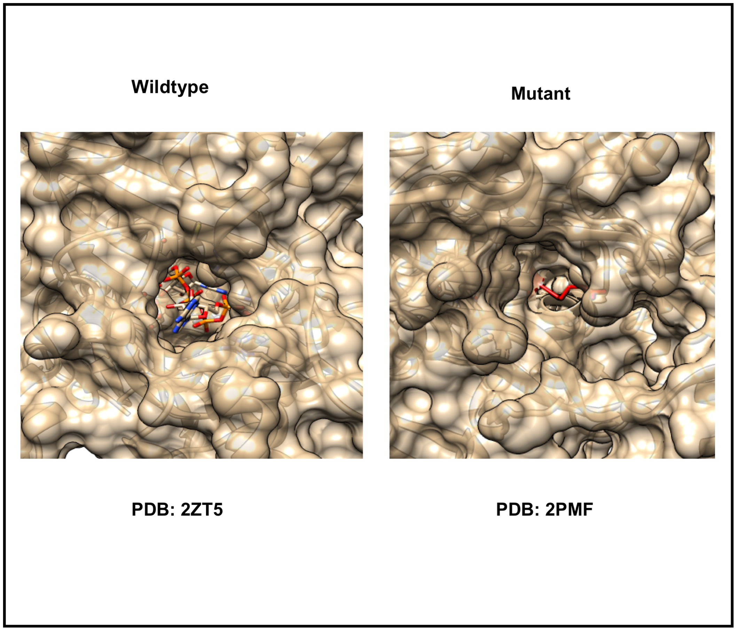

**Пример 3. Stability.**

58 of 374 SNV related changes in our dataset (~16%) lead to reduced protein stability.

DJ-1 (mutant PDB: 2RK4) is a small conserved protein (189 amino acids), whose absence or inactivation leads to rare forms of familial Parkinsonism in humans [[52](https://journals.plos.org/plosone/article?id=10.1371/journal.pone.0171355#pone.0171355.ref052)]. It is also a Ras-dependent oncogene and has been associated with several types of cancers [[53](https://journals.plos.org/plosone/article?id=10.1371/journal.pone.0171355#pone.0171355.ref053)]. The Met→Ile (M26I) mutation (rs74315351) decreases thermal stability and enhances formation of DJ-1 aggregates [[54](https://journals.plos.org/plosone/article?id=10.1371/journal.pone.0171355#pone.0171355.ref054)]. M26 (Wildtype PDB: 1P5F) is a conserved residue, located in the hydrophobic core of the protein. Although M26 lies near the dimer interface, it does not directly participate in intermolecular protein-protein interactions across the dimer interface. The M26I mutation introduces a β-branched amino acid (isoleucine) into the tightly packed hydrophobic core of the DJ-1 monomer. The steric clash between I26 and the sidechain of I31 displaces the residues slightly and causes loss of optimal packing contacts in the interior of the protein resulting in lower stability.

**Визуализировать мутацию** Met→Ile (M26I) в белке 1P5F

Найти запись о SNP rs74315351 в базе данных dbSNP

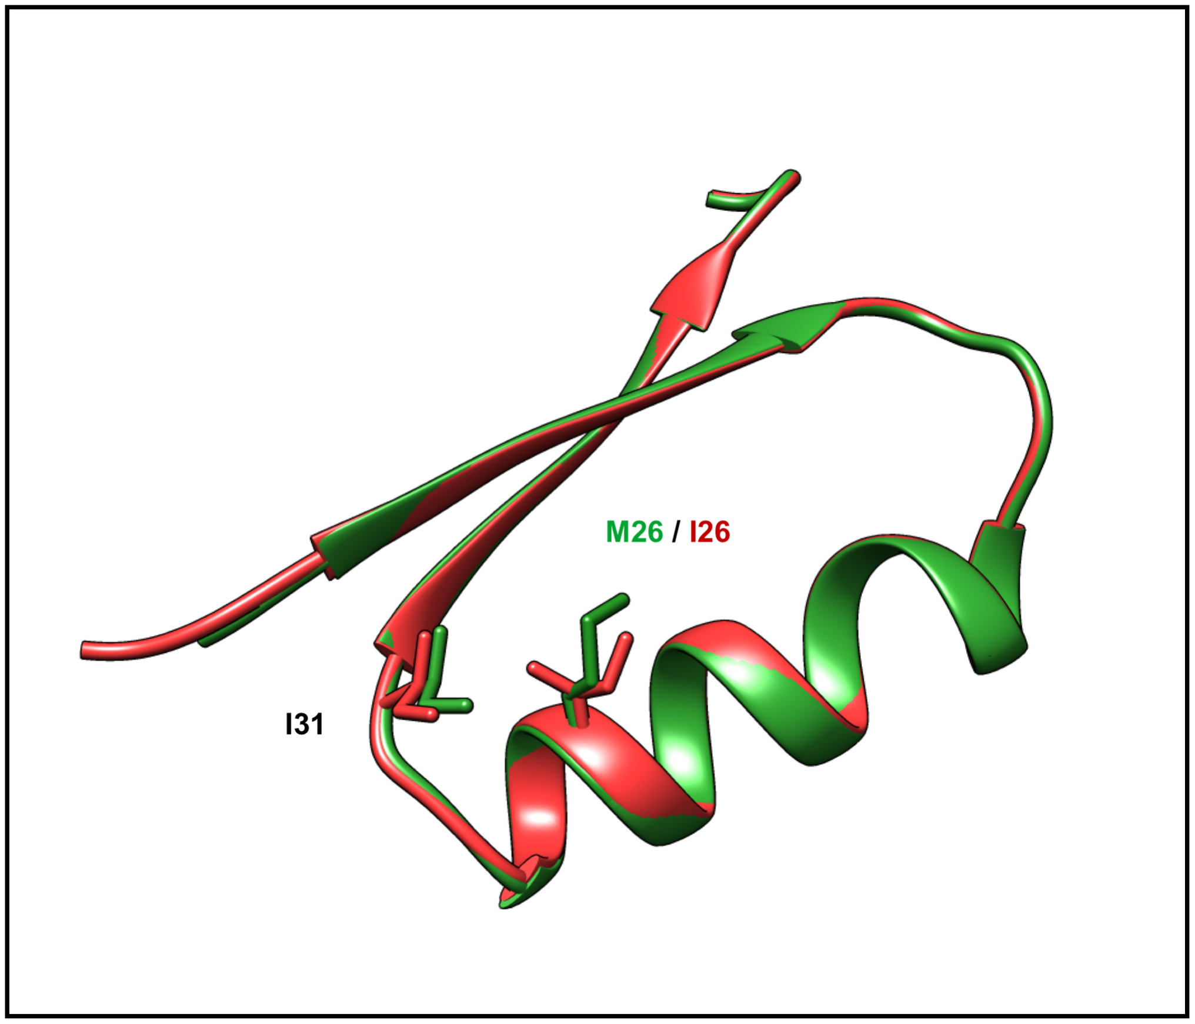

**Пример 4. Binding.**

44 of 374 SNV related changes in our dataset (~12%) affect ligand or macromolecule binding properties of the protein. A SNV can change the affinity of binding to partners, such as activators, repressors, or substrates. Such changes can also affect the kinetics of interactions with partners or alter binding specificity. Structurally, a SNV can alter the binding site of the protein, which can in turn affect interactions with partner proteins, ligands, etc. The Lys→Arg (K117R) (rs104894227) substitution in HRAS (mutant PDB: 2QUZ) does not alter either intrinsic Ras GTPase activity or responsiveness to GTPase activating proteins, but instead causes constitutive activation of HRAS (and downstream targets) by markedly increasing the rate of GDP dissociation [[55](https://journals.plos.org/plosone/article?id=10.1371/journal.pone.0171355#pone.0171355.ref055)]. This mutant HRAS protein activates the RAF/MEK/ERK signaling cascade, leading to growth factor independent cellular proliferation. Although lysine and arginine are both positively charged amino acids, even this conservative substitution results in constitutive activation of HRAS [[55](https://journals.plos.org/plosone/article?id=10.1371/journal.pone.0171355#pone.0171355.ref055)]. Clinically, the K117R change in HRAS leads to constant and unchecked cell division causing Costello Syndrome [[55](https://journals.plos.org/plosone/article?id=10.1371/journal.pone.0171355#pone.0171355.ref055)], which is a rare genetic disorder affecting many parts of the body.

The Lys→Arg substitution at position 117 maps to the nucleotide-binding consensus sequence NKXD. In wild-type HRAS (Wildtype PDB: 2CE2), K117 stabilizes nucleotide binding when its aliphatic portion interacting with the base, while its terminal amino group interacts with ribose oxygen O4 of N85 and with a main chain segment (Gly13, CO) from the phosphate binding loop (P-loop)[[55](https://journals.plos.org/plosone/article?id=10.1371/journal.pone.0171355#pone.0171355.ref055)]. Destabilization of nucleotide binding is a consequence of subtle rearrangements due to introduction of a larger sidechain capable of making additional polar interactions [[55](https://journals.plos.org/plosone/article?id=10.1371/journal.pone.0171355#pone.0171355.ref055)].

**Визуализировать мутацию** Lys→Arg (K117R) в белке 2CE2

Найти запись о SNP rs104894227 в базе данных dbSNP

Если останется время, то можно изучить другие SNVs из статьи.